Addison Township Public Library New Building Update
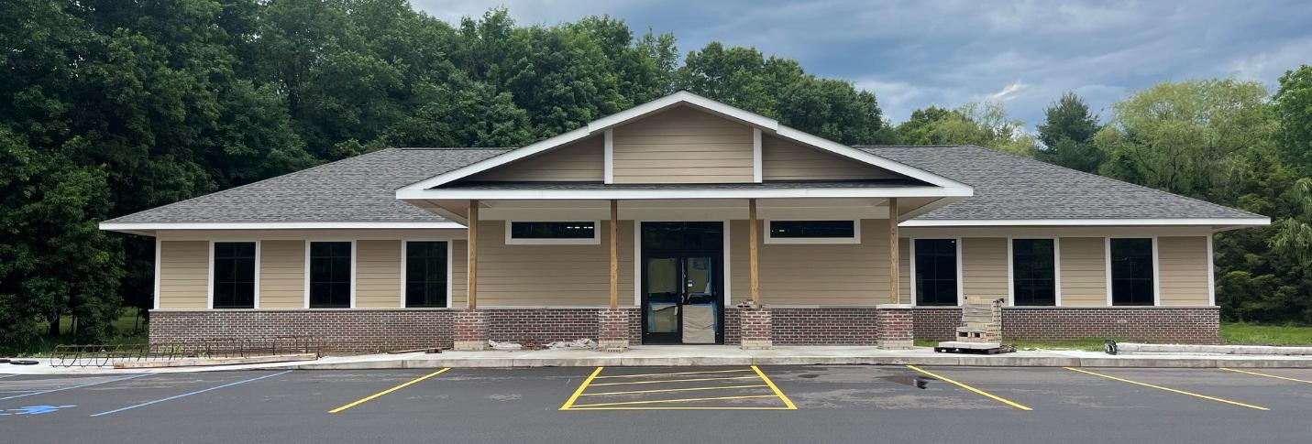
Date: 6/16/2026

Construction Progress and Updates
- Engraved bricks installed. Pilar caps will be picked up this week.
- Mechanical, Electrical and Plumbing plans still waiting approval from Township. Southeast Commercial has contacted an engineering resource to complete needed drawings.
- Well has been installed. Need to complete cleaning a testing process for full well approval.
- Construction of dumpster enclosure complete.
- Final site grading will begin.
- Parking lot lines and parking bumpers installed.
- Requirements for egress in the basement have been provided. 3 window wells will be installed. See image below for installation areas under review. Final location will be determined but 50ft access requirement.
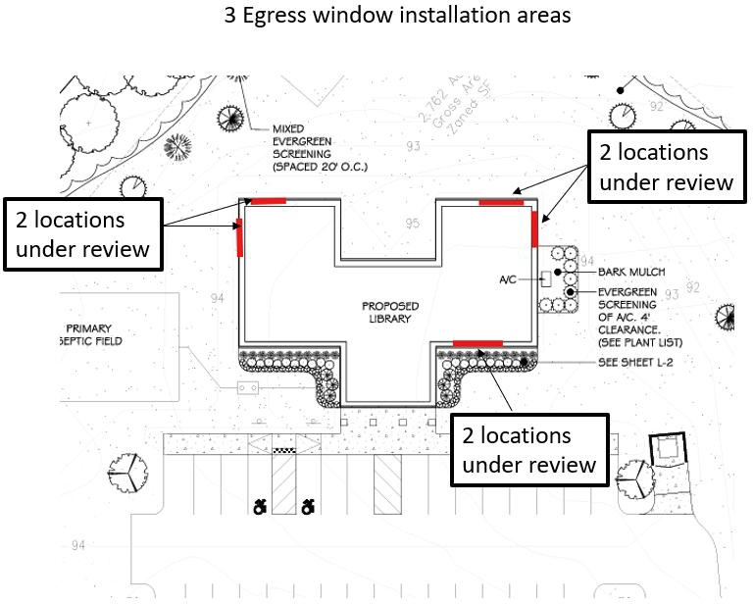

Committee Tasks
- Continuing communication with TLN to coordinate building electrical and data wiring.
  - Requirements for IT equipment in basement has been provided to southeast commercial. Installation is being planned.
- Work with South East Commercial on interior finishes
- Review potential options for exterior signage on the building (“Addison Township Public Library” sign) shown below.
  - Committee should start talking to Southeast to understand sign lighting and any special sign requirements.
  - Concepts shown below
Sign Company Rendering
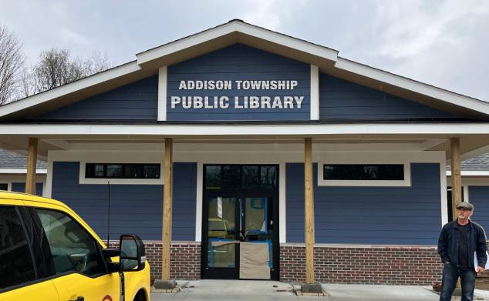
Architect Rendering
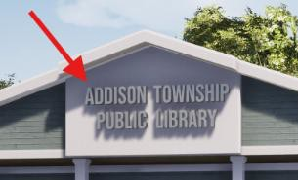

Progress Pictures

Well
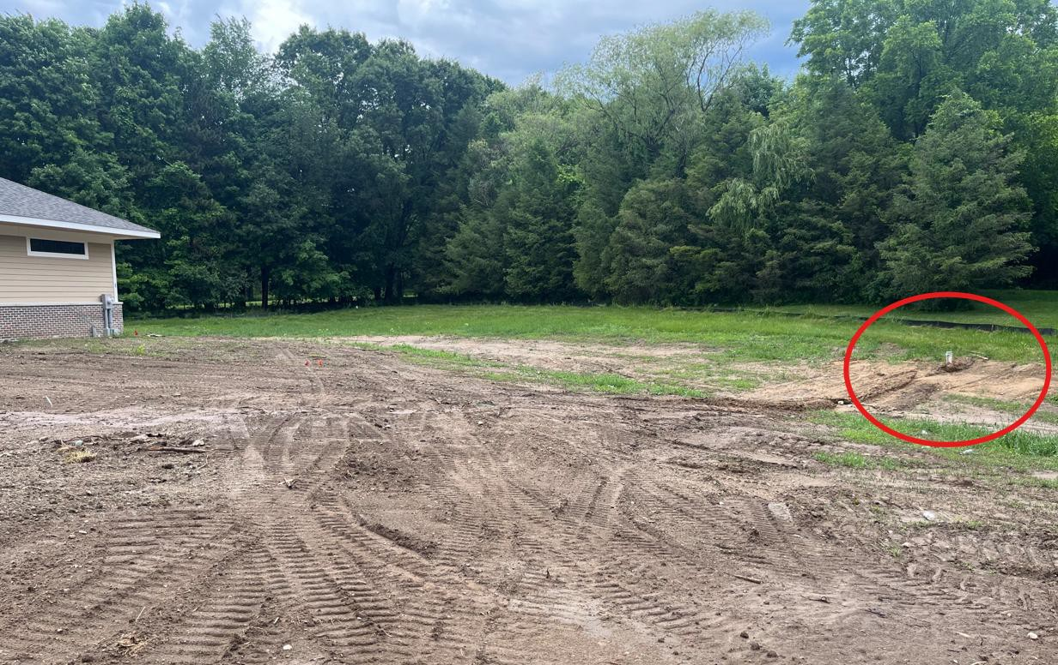
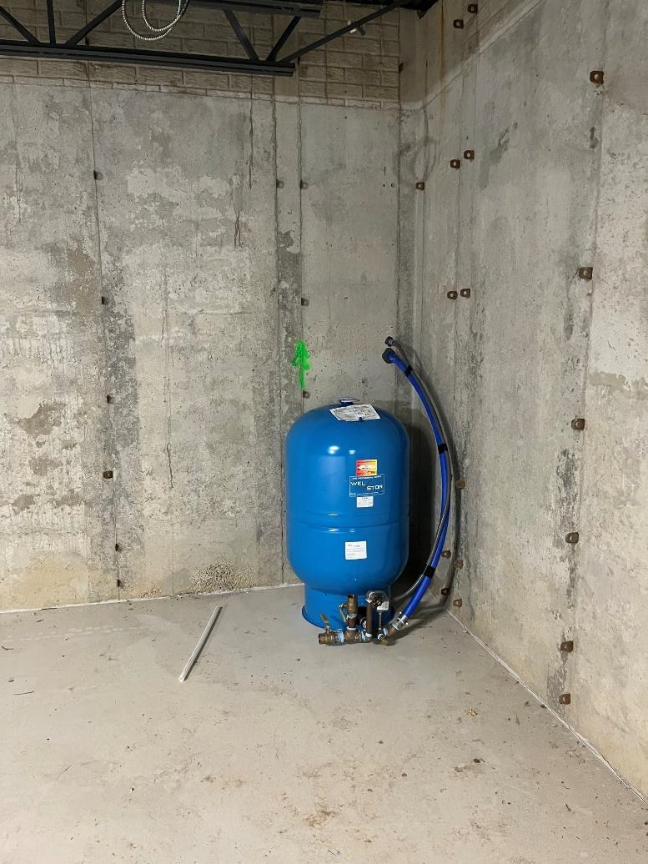

Engraved bricks
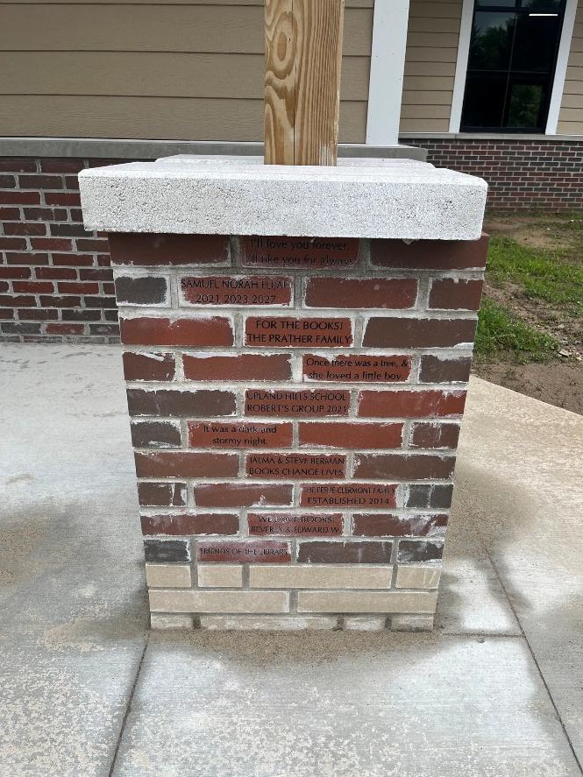
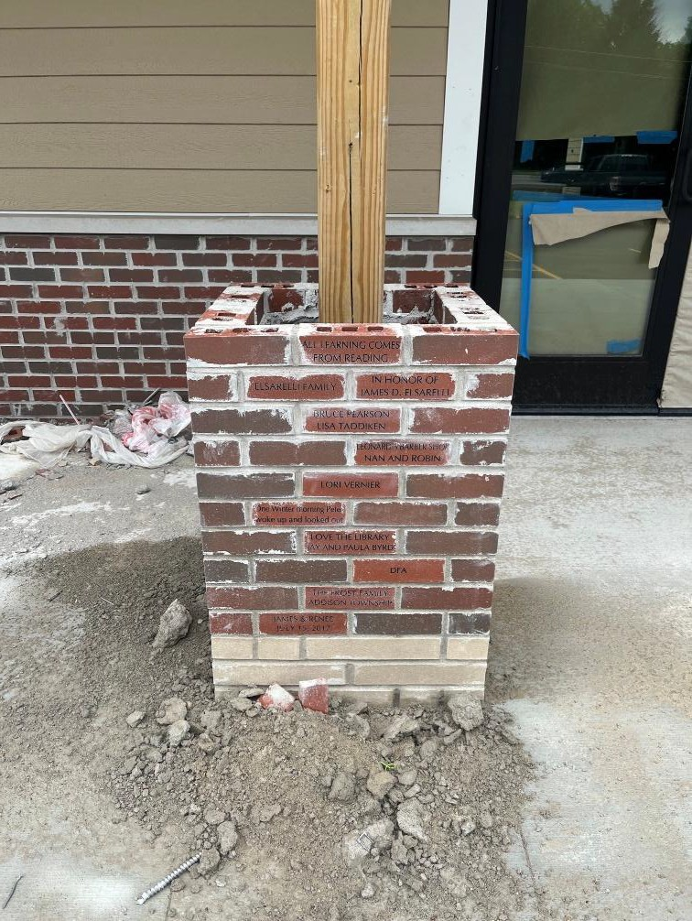

Parking Lot
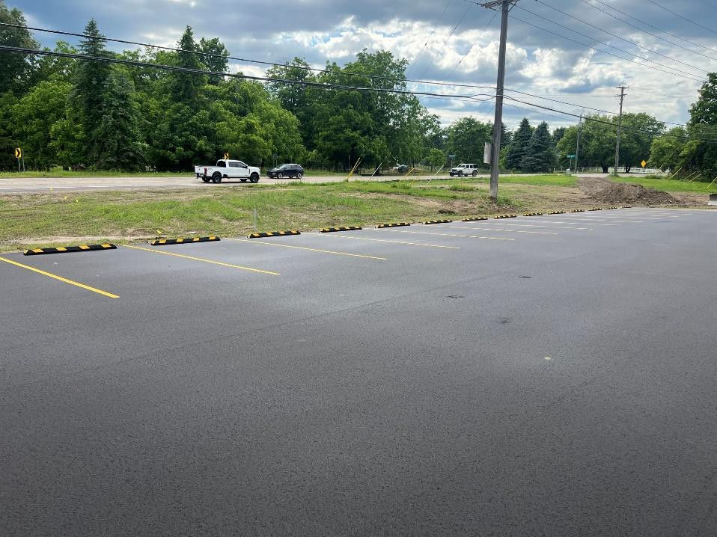

Dumpster Enclosure
